**SMART WATER CONTROL SYSTEM.**

**BY**

**M.B. NADESHA SHALOM DIAS**

**A PROJECT SUBMITTED TO**

**PIONEER INSTITUTE OF BUSINESS & TECHNOLOGY**

**(PIBT)**

**THE PROJEGECT PROPOCAL**

**FOR THE**

**HND SOFTWARE ENGINEERING**

Table of Contents

Introduction 3

Current situation leading to problem identification 4

Proposed technique to solve the current problem 5

Feasibility 6

Project Description 9

Deliverables 11

Resources required 12

HARDWARE 12

SOFTWARE 12

Expected output and outcome 13

Limitations 15

References 16

Introduction

## The project proposal is base on a brief description of the purpose of watering plants using a smart system and the implementation steps for the proposed system.

## In this busy world, everyone is busy and working endlessly. They also have employees who do different jobs. This includes the farming community as well. Due to this their productivity has faced a risk.

## Smart water control systems are automated programs that control the water needed by plants. The app on the mobile phone connects to the electronic devices over the internet and shows whether plats’ required amount of water is sufficient and even after obtaining the required volume of water. This process includes many electronic devices and sensors to read values for plats and provide processed data to end-users to monitor every plan in their farmhouse. This includes a manual process as well as an automated process.

## When we issue that command via a tablet or smartphone, the smart water control system reacts and the response can be monitored via the smartphone from anywhere. This allows them to be an active partner in managing the busy lives and save time as well. This is very important for farmers as it performs several desired functions.

## As a Software Engineering student at the PIBT Campus, I take this as my HND Software Engineer final project and will do what we can to control and facilitate plantation water management for farmers. This is very important for farmers who lead a very busy life and can see the condition of the soil and condition from a distance.

## The proposal also includes a proper solution for the problem by providing a project description, feasibility report, current demand and a description of the proposed system outputs.

The current situation leading to problem identification

## People in this 21st century are living in a technological age. They need technical assistance to make their daily lives easier. Due to the current busy schedule, there are times when farmers do not have time to go to their fields. The idea came to me to introduce such a methodology to prevent that situation.

## I interviewed several farmers in the society and identified the following.

## Farmers have responsibilities in addition to maintaining the farm, so they may not be able to focus on every task at a time. He may have not time to check plants one by one and then the farmer will not be able to look after that day as it should.

## Due to this busy schedule, farmers may miss taking care of every plant. So if the water supply, which is the main factor required for plats, is not maintained properly, it can cause damage to the farm and cause losses to the farmer. On some days the farmer provides water for cultivation but when he has enough water he forgets to stop getting water is another reason.

## Taking all these factors into consideration, the farmer may forget to provide fertilizers and pesticides required for cultivation. That omission also contributes to crop failure and large losses. Also, there are times when the farmer is helpless when no one is at home or the farmer is sick. Then the farmer should check the condition of the crop without going to the paddy field.

## The farmer is concerned about these issues, family issues, and cost issues. As a result, others in the home may not be able to focus on their work, they may neglect their responsibilities, and they may not care about the farm.

## But the main reason for activating this smart water management system is for busy farmers to manage water more responsibly and manage their time. My model as a software engineering student is to manage this as the first step in my life who wants to work on time, this project is based on my interest and I intend to control this as the first step in a model farm.

The proposed technique to solve the current problem

## I hope to implement an Arduino based smart water control system to overcome the problem that I have identified. I will create a better and more comfortable environment for farmers to manage their farms easily.

## The system contains sensors and controls the sensors using the smartphone located in the Wi-Fi location. The Arduino program will read the data sent from sensors and will process the temperature, Humidity, soil measure of a plant and then will process the received values from sensors to check whether it’s required to water plants. There are two different ways that a farmer can water plants. One way is to water plants manually using the smartphone app or let the system handle it for farmers.

## So the second option is that the system will automatically read plant details using sensors and it will automatically decide whether to water plants based on values received by sensors. If values meet all the predefined criteria, The system will automatically start watering plants. And then the system will read sensors while watering plants to protect plants from overwatering. So that the plants will be protected when the automated process runs on plats.

## There’s another option which is provided by the system to measure the water levels in tanks. So the farmer can have a better idea about the water stock he has for plants and fill the tanks if requires.

Feasibility

**Executive Summary**

## The main purpose of making this report is to identify the importance of feasibility studies in implementing a new method. Stages of feasibility studies such as scheduling, technical, economic, operational, and legal help to implement a system without any problems and to identify the project's accuracy, and to successfully manage the system according to the client's need and idea. feasibility studies, costs, and benefits are more accurately assessed to find a way to invest and recoup.

**Introduction**

## Feasibility studies continue when management accepts the proposal, and the main objective of feasibility studies is not to solve the problem but to achieve the scope. The feasibility report finds a way to recoup the investment by following certain stages such as technical, economic, legal, operational, and schedule.

**Product**

## The proposed smart water control system will be implemented to address the problems of water scarcity and farmer time saving, while the proposed system will facilitate farm automation, assist users, and activate the system through user intervention and exploration.

**Cost Feasibility**

## According to this smart water control system, it cost approximately 6,500LKR for all the hardware parts which is a need to complete the project.

## Below I have listed the hardware devices that cost to build the smart water control system;

* Arduino Uno R3 board
* Bread Board
* Nod MCU (esp8266)
* Temperature and humidity sensor (DHT-22 sensor)
* Soil humidity sensor
* Relay Board
* Jumper Wires
* Wires to connect to the Relay
* Resistors
* WIFI router
* Water pump
* Water flow sensor
* Real-Time Clock
* Ultrasonic sensor
* Watering tube
* 9v battery connector with dc jack
* 9v battery

## We have spent so much money on hardware devices for a better solution in smart farming than the usual cultivation. In this developed world, everyone is busy in their way, but once you activate smart farming it helps to create an efficient farming environment. Also, we can use it for farming field without any cost more than the initiation time. Smart cultivation can be a valuable investment to increase its market value and attract buyers in the future.

## The next one is an opportunity cost that if I will not able to finish the system I would not get a Higher National Diploma (HND) which is considered a huge loss to me.

**Time Feasibility**

## Want to implement this system in the period that the management has provided. if I will not be able to finish the project on time and there was no use in the implementation. so finish the project on time is a priority task during this project. so it is must provide a timetable or a schedule to implement this for the time-period that management provided which is 12weeks. I have to manage this time-period according to the functions and all the required documents and implementation process.

## **Time Feasibility**

|  |  |
| --- | --- |
| **Function** | **Time-Period** |
| Learning Process | 6 days |
| Requirement Gathering | 4 days |
| Hardware part connection | 1 week |
| Coding the Hardware Part | 1 week |
| Coding the System Part | 1 week |
| Creating the Mobile Application | 6 days |
| Connect the hardware with Mobile application | 4 days |
| Testing and error clearing the Mobile app with the Arduino Board | 5 days |
| Provide maintenance | 5 day |
| Fully complete the system without any issues | 5 days |
| **Total time required** | **8 weeks** |

**Scope Feasibility**

## The proposed Arduino Smart Water Management System is not limited to a single function of watering tassk, but also measures soil quality, temperature calculation, and soil drying as the temperature rises. The water is then supplied automatically when there is no water in the soil. It notifies the farmer on the app. In this project, I will cover the water supply system to provide a better system and use the approved technologies available in the system using basic hardware and software. The main reason for choosing this scope is to provide a light life, conserve resources without wasting water unnecessarily, and save time. Also, there is a manual process that farmers can see plant details and water manually. But the manual watering method also includes some automated process which is to protect plants from overwatering.

**Technical Feasibility**

## I used both software and hardware components to develop the smart water control system, and the system required both hardware and technology.

Hardware Devices

* Arduino Uno R3 board
* Bread Board
* WI-FI shield
* Relay Board
* Jumper Wires
* Water flow sensor
* Wires to connect to the led to the Relay
* Resistors
* Real-Time Clock
* Nod MCU (esp8266)
* Temperature and humidity sensor
* Soil humidity sensor
* Water pump
* Ultrasonic sensor
* Watering tube

Software Requirement

* Android SDK
* Visual Studio Code
* Arduino IDE
* MYSQL database
* Intellij Idea CE

Programming Languages

* Java
* Flutter
* C++

Project Description

## The power supply system of the plant is covered by a smart water management system. I use the open-source approved hardware, basic hardware, and software in the system. So, I choose one part of the project because everyone can choose the project of making it a smart plantation.

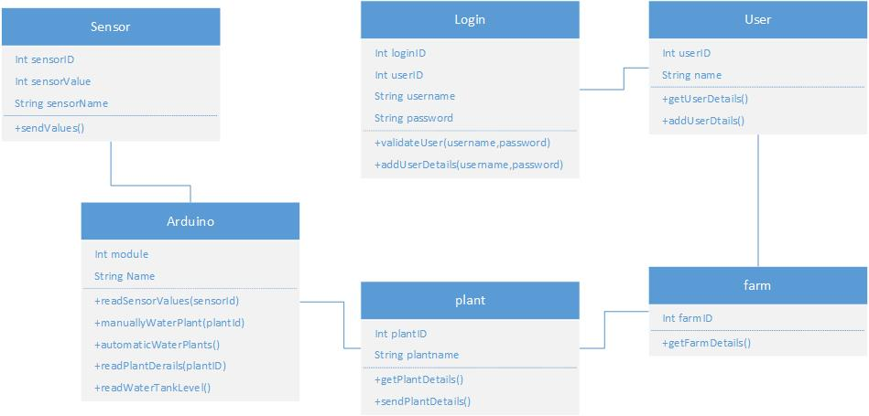

## The first step in the project is to complete the application development process using the Java language through the Visual Studio Code. In the next step, we will connect the soil humidity sensor/water flow sensor/ Ultrasonic Sensor / other components including temperature and humidity to the Arduino panel. The code that controls hardware devices must be enabled. Once the coding process starts, we need to use the Arduino IDE.

## After this process, we can use the USB cable to transmit the code to the device. Using the Wi-Fi connection, the user can use the APP to remotely control other devices, including the soil humidity sensor/water flow sensor/temperature and humidity sensor / ultrasonic sensor, and control the process automatically and manually.

Use case Diagram

## This is the use case diagram of which the system is working. it give an idea,according to all of us can take an idea how the process of smart water control system.

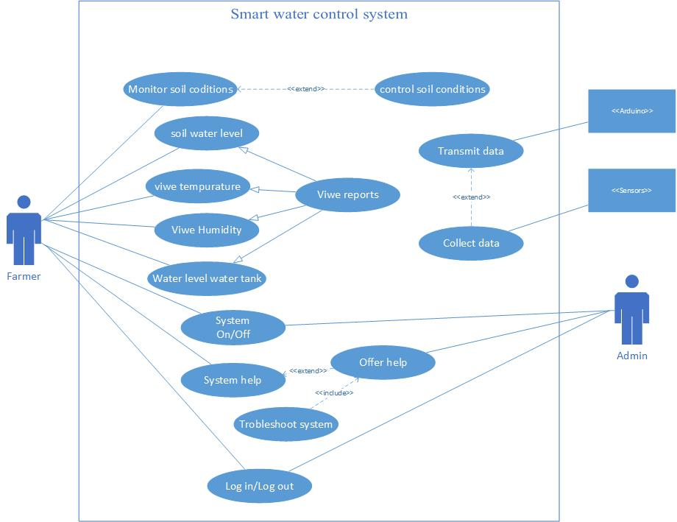

Deliverables

## This project is considered as a combination of both hardware and software and as the first stage, it is to develop the mobile app, and the second stage is the hardware part which is to analyze and assemble required hardware for functioning according to the requirement and operation of those hardware components. And the third stage is the database designing and connection part. Also, the final stage of the system is to create the process of automatic, manual watering process and checking statics using the app. Each of these stages having deliverables and the output of those deliverables should works correctly for the success of the system.

## 1ST Stage Deliverable- the mobile app implementation and coding should have to work and the build process should have to display a success message and the app should have to deploy to the mobile without any errors this is considered the first deliverable.

## 2nd stage deliverable- The hardware configuration part and Arduino codes should have to upload to the hardware without any errors that are a first deliverable and the sensors should have to work based on the comments that are also a deliverable.

## 3rd stage Deliverable – Database design to store data received by sensors and create connections accordingly.

## Phase 4- The window application data should be displayed for the training process. Training Data Exhibition can be provided for this stage.

## Phase 5 – Implement the manual and automatic watering methods to handle the hardware according to the functions. And also implement codebase to support to read sensor values such as water stock level. This will be a web service written in Java.

Resources required

HARDWARE

## **Arduino Uno R3 board** - It has 14 digital input/output pins 6 analog inputs, a USB connection, a power jack, reset button, and more. Also, it contains everything needed to support the microcontroller; simply connect it to a computer with a USB cable or power it with an AC-to-DC adapter or battery to get started.

* **Breadboard -** Helps for connecting all the hardware components together such as sensors and wires
* **Jumper wires** - used for making connections between items on the breadboard and Arduino Header pins.
* **Wires** - Used to connect the relay and battery
* **Nod MCU (esp8266)** – Node MCU is a low-cost open-source IoT platform. It initially included firmware that runs on the ESP8266 Wi-Fi SoC from Espresso Systems and hardware that is based on the ESP-12 module.
* **Router** - Use for the network connection.
* **Resistors -** used to limit the amount of current going to certain.
* **RTC** – Get current time from Arduino to create records
* **Relay board** – Relay boards are computer boards with an array of relays and switches. They have input and output terminals and are designed to control the voltage supply. Relay boards provide independently programmable, real-time control for each of several onboard relay channels.
* **Water flow sensor** – Used to measure the rate at which water flows and the amount of water that flows.
* **Ultrasonic sensor** – An ultrasonic sensor is an electronic device that measures the distance.
* **Temperature and Humidity sensor** – It measures temperature and air quality.
* **Soil moisture sensor** – Sensor connected to an irrigation system controller that can measure soil moisture.
* **Water pump –** Uses this for water transport.
* **9v battery connector –** This can connect the battery strip on a standard 9V battery and connect the other end to any device that requires 9V.
* **9v battery –** To supply the current for the Arduino board and other components

Expected output and outcome

The expected return of the project is that the water supply should be activated and deactivated with and without human intervention. This means that it must be activated and deactivated on time. Air humidity and temperature should also be measured and shown to the user in the UI.

Limitations

## Gathering the needed requirements for the implementation is considered as one of the important factors to find out the requirements I conducted a research very carefully and find out its limitations and shortcomings.

## The research was conduct by me for one week time period. A one-week duration is not enough for the researchers to observe the problems and the requirements needed by the society or the client. It would be better if it was done in a long time.

## Second, the population experimental group is laid between law numbers. I could only interview a small group of people like 5 farmers and the majority of them are farm owners

## Scope Limitation The project covers only one or two plants and controls the water using the app.

## Human resources limitation for project completion. I am going to do the entire project by myself with the guidance of supervisors. so I should have to put my entire focus to finish the project including hardware designing, software implementation, and testing.

References

(Creately, 2008 - 2020)

*Creately*. (2008 - 2020). Retrieved from https://creately.com/diagram/example/htlepo7i2/UML%20Arduino

(Electronicshub, 2020)

*Electronicshub*. (2020). Retrieved from https://www.electronicshub.org/arduino-project-ideas

(Arduino, 2021)

*Arduino*. (2021). Retrieved from arduino.cc: https://www.arduino.cc/